**AUTOMATIC TIME TABLE GENERATION**

**ABSTRACT**

**PROBLEM STATEMENT:** AUTOMATIC TIME TABLE GENERATION

In this report, we present the detailed development and implementation of automatic time table generation. This consists of admin interface, user interface implemented using HTML and CSS.

Timetable generation without clashes is the hectic task in most of the educational institutions that takes more time and manpower. The proposed system of our project will generate timetable more efficiently in less time. This system will take various inputs like number of classes, number of teachers, prior subjects and accordingly it will generate a timetable efficiently.

**Existing System:**

Previously timetables were manually made by the head of the departments that involves a lot of manual work and is a time consumptive process.

**Proposed System:**

This system will help the colleges, schools and many organisations to generate the time table automatically without any manual work load and saves a lot of time that plays a prominent role in the present life style.

**SOFTWARE REQUIREMENTS:**

1.OPERATING SYSTEM: WINDOWS 11

2.DATABASE: HEIDISQL

3.IDE: NETBEANS

**HARDWARE REQUIREMENTS:**

1.PROCESSOR

2.HARD DISK

3.RAM

**TECHNOLOGIES USED:**

1. FRONE-END: HTML, CSS, JAVASCRIPT
2. BACK-END: JAVA
3. DATABASE: HEIDISQL
4. SERVER: TOMCAT

**SOFTWARE:**

**JAVA:**

Java technology is both a programming language and a platform.

### The Java Programming Language

### The Java programming language is a high-level language that can be characterized by all of the following buzzwords:

* Simple
* Architecture neutral
* Object oriented
* Portable
* Distributed
* High performance
* Interpreted
* Multithreaded
* Robust
* Dynamic
* Secure

With most programming languages, you either compile or interpret a program so that you can run it on your computer. The Java programming language is unusual in that a program is both compiled and interpreted. With the compiler, first you translate a program into an intermediate language called Java byte codes —the platform-independent codes interpreted by the interpreter on the Java platform. The interpreter parses and runs each Java byte code instruction on the computer. Compilation happens just once; interpretation occurs each time the program is executed. The following figure illustrates how this works.

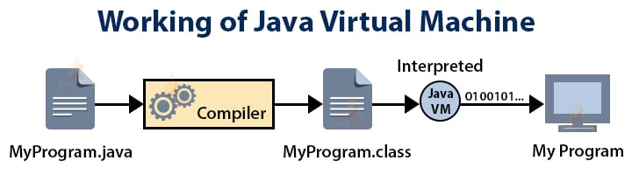

You can think of Java byte codes as the machine code instructions for the Java Virtual Machine (Java VM). Every Java interpreter, whether it’s a development tool or a Web browser that can run applets, is an implementation of the Java VM. Java byte codes help make “write once, run anywhere” possible. You can compile your program into byte codes on any platform that has a Java compiler. The byte codes can then be run on any implementation of the Java VM. That means that as long as a computer has a Java VM, the same program written in the Java programming language can run on Windows 2000, a Solaris workstation, or on an iMac.

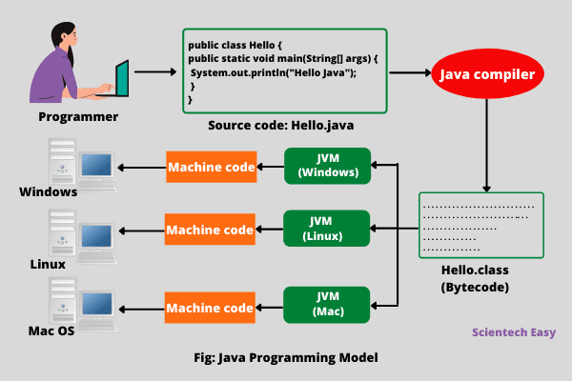

**HTML:**

HTML stands for Hyper Text Markup Language. HTML is a standard markup language for creating web pages and it describes the structure of the webpage. The HTML was created for enabling the user structure sections, paragraphs, headlines, links for applications and website pages, and blockquotes.

**Advantages of HTML**

The benefits of HTML are as follows.

* HTML can be easily integrated with various backend languages such as PHP, Node.js.
* HTML is one of the most popular and widely used languages that contains numerous resources and has a big community.
* HTML has a flat learning curve and it can be easily run on all web browsers.
* HTML is one of the most simple markup languages that you can work with.
* HTML is open-source and completely free.
* The web standard for HTML is maintained by World Wide Web Consortium (W3C).

**OBJECTIVE OF HTML:**

HTML is primarily used for structuring the web pages according to the functional requirements of the respective web pages. For instance, if you need to create your touring website then you can add rich text changes, graphical interface, and other elements with HTML. So essentially HTML is the perfect tool for making changes to the webpage whenever it is required. HTML utilises several elements for providing and editing the structure of the web pages on the internet

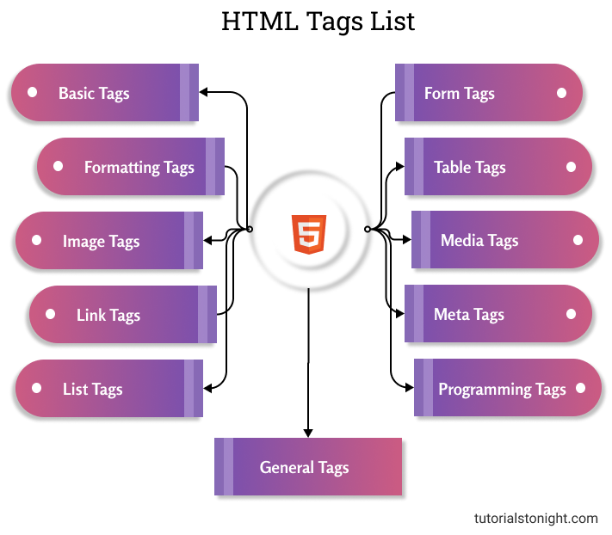

|  |  |
| --- | --- |
| HTML TAGS | DESCRIPTION |
| <html> ... </html> | Declares the Web page to be written in HTML |
| <head> ... </head> | Delimits the page's head |
| <title> ... </title> | Defines the title (not displayed on the page) |
| <body> ... </body> | Delimits the page's body |
| <b>...</b> | Set... in boldface |
| <center> ... </center> | Center ... on the page horizontally |
| <ul> ... </ul> | Brackets an unordered (bulleted) list |
| <ol>...</ol> | Brackets a numbered list |
| <br> | Forces a line break here |
| <p> | Starts a paragraph |
| <img src="..."> | Displays an image here |
| <a href="..."> ... </a> | Defines a hyperlink |

**CSS:**

The css full form is Cascading Style Sheets which is a popular designing language. It makes presenting webpages a more straightforward task and is quite a simple language to operate. CSS handles the look and feel part of the web page designing and you can control the color, fonts, icons, line spacing, column sizing, background designs, etc.

**Framework for CSS**

Framework is a set of concepts or practices that are used to deal with structural problems. Few widely used open-source CSS frameworks are:

**1. Foundation**

It is the most responsive front-end framework for Cascading Style Sheets . It is quite an elaborate and sophisticated framework.  Facebook, Disney, Cisco, and others use Foundation for building their websites. Features of this framework are:

* Classic UI design and responsive HTML templates
* Vertical layouts for timeline
* An interactive platform from front-end solutions

**2. Bootstrap**

It is the most widely used and popular part in understanding the css full form, meaning and framework. The current version is Bootstrap4 and is supported by LESS and SASS. Some of its features are:

* Uses Flexbox
* Good documentation process
* Inculcates good practices by combining both HTML and JavaScript elements

**3. Pure**

This is a lightweight CSS framework version that was developed by Yahoo in 2014. It is built using Normalize.css and helps to create responsive layouts using grids and menus. Some features of this system are:

* Mobile-friendly technology
* Simple to learn and operate
* Minimizes downtime and easy UI blots

**Advantages of CSS**

There are some distinct advantages of Cascading Style Sheets that make it a popular framework over others:

1. The CSS framework makes it easy for search engines to read your web content. So, it will be easier for people to locate you on the web.
2. CSS frameworks create printer-friendly web pages. Style sheets can be easily customized according to your printer version using advanced color options.
3. It is easy to separate your content from the presentation using CSS. A single file can be used to control multiple webpages and this program also saves you enough time.
4. Style sheets effectively reduce the loading time of the web pages to a greater extent. CSS separates your website from the server amounting to superfast webpage loading.

**JavaScript**

JavaScript is a scripting language used to create and control dynamic website content, i.e. anything that moves, refreshes, or otherwise changes on your screen without requiring you to manually reload a web page.

Features like:

animated graphics

photo slideshows

autocomplete text suggestions

interactive forms

An even better way of understanding what JavaScript does is to think about certain web features you use every day and likely take for granted—like when your Facebook timeline automatically updates on your screen or Google suggests search terms based on a few letters you’ve started typing. In both cases, that’s JavaScript in action.

The results of JavaScript may seem simple, but there’s a reason why we teach an entire segment on JavaScript in both our FrontEnd Web Developer and Break into Tech Blueprints. Underneath all those great animations and autocompletes—there’s some pretty fascinating stuff happening. This guide will break down exactly how JavaScript works and why and how to use it, plus the best ways to learn JavaScript if you’re realizing you need it in your skillset.

* JavaScript is a lightweight, interpreted programming language.
* It is designed for creating network-centric applications.
* It is complimentary to and integrated with Java.
* JavaScript is very easy to implement because it is integrated with HTML.
* It is open and cross-platform.

### ODBC

Microsoft Open Database Connectivity (ODBC) is a standard programming interface for application developers and database systems providers. Before ODBC became a de facto standard for Windows programs to interface with database systems, programmers had to use proprietary languages for each database they wanted to connect to. Now, ODBC has made the choice of the database system almost irrelevant from a coding perspective, which is as it should be. Application developers have much more important things to worry about than the syntax that is needed to port their program from one database to another when business needs suddenly change.

Through the ODBC Administrator in Control Panel, you can specify the particular database that is associated with a data source that an ODBC application program is written to use. Think of an ODBC data source as a door with a name on it. Each door will lead you to a particular database. For example, the data source named Sales Figures might be a SQL Server database, whereas the Accounts Payable data source could refer to an Access database. The physical database referred to by a data source can reside anywhere on the LAN.

The ODBC system files are not installed on your system by Windows 95. Rather, they are installed when you setup a separate database application, such as SQL Server Client or Visual Basic 4.0. When the ODBC icon is installed in Control Panel, it uses a file called ODBCINST.DLL. It is also possible to administer your ODBC data sources through a stand-alone program called ODBCADM.EXE. There is a 16-bit and a 32-bit version of this program and each maintains a separate list of ODBC data sources.

From a programming perspective, the beauty of ODBC is that the application can be written to use the same set of function calls to interface with any data source, regardless of the database vendor. The source code of the application doesn’t change whether it talks to Oracle or SQL Server. We only mention these two as an example. There are ODBC drivers available for several dozen popular database systems. Even Excel spreadsheets and plain text files can be turned into data sources. The operating system uses the Registry information written by ODBC Administrator to determine which low-level ODBC drivers are needed to talk to the data source (such as the interface to Oracle or SQL Server). The loading of the ODBC drivers is transparent to the ODBC application program. In a client/server environment, the ODBC API even handles many of the network issues for the application programmer.

The advantages of this scheme are so numerous that you are probably thinking there must be some catch. The only disadvantage of ODBC is that it isn’t as efficient as talking directly to the native database interface. ODBC has had many detractors make the charge that it is too slow. Microsoft has always claimed that the critical factor in performance is the quality of the driver software that is used. In our humble opinion, this is true. The availability of good ODBC drivers has improved a great deal recently. And anyway, the criticism about performance is somewhat analogous to those who said that compilers would never match the speed of pure assembly language. Maybe not, but the compiler (or ODBC) gives you the opportunity to write cleaner programs, which means you finish sooner. Meanwhile, computers get faster every year.

**JDBC**

In an effort to set an independent database standard API for Java; Sun Microsystems developed Java Database Connectivity, or JDBC. JDBC offers a generic SQL database access mechanism that provides a consistent interface to a variety of RDBMSs. This consistent interface is achieved through the use of “plug-in” database connectivity modules, or drivers. If a database vendor wishes to have JDBC support, he or she must provide the driver for each platform that the database and Java run on.

To gain a wider acceptance of JDBC, Sun based JDBC’s framework on ODBC. As you discovered earlier in this chapter, ODBC has widespread support on a variety of platforms. Basing JDBC on ODBC will allow vendors to bring JDBC drivers to market much faster than developing a completely new connectivity solution.

JDBC was announced in March of 1996. It was released for a 90 day public review that ended June 8, 1996. Because of user input, the final JDBC v1.0 specification was released soon after.

The remainder of this section will cover enough information about JDBC for you to know what it is about and how to use it effectively. This is by no means a complete overview of JDBC. That would fill an entire book.

### JDBC Goals

Few software packages are designed without goals in mind. JDBC is one that, because of its many goals, drove the development of the API. These goals, in conjunction with early reviewer feedback, have finalized the JDBC class library into a solid framework for building database applications in Java.

The goals that were set for JDBC are important. They will give you some insight as to why certain classes and functionalities behave the way they do. The eight design goals for JDBC are as follows:

1. **SQL Level API**

The designers felt that their main goal was to define a SQL interface for Java. Although not the lowest database interface level possible, it is at a low enough level for higher-level tools and APIs to be created. Conversely, it is at a high enough level for application programmers to use it confidently. Attaining this goal allows for future tool vendors to “generate” JDBC code and to hide many of JDBC’s complexities from the end user.

1. **SQL Conformance**

SQL syntax varies as you move from database vendor to database vendor. In an effort to support a wide variety of vendors, JDBC will allow any query statement to be passed through it to the underlying database driver. This allows the connectivity module to handle non-standard functionality in a manner that is suitable for its users.

1. **JDBC must be implemental on top of common database interfaces**  
    The JDBC SQL API must “sit” on top of other common SQL level APIs. This goal allows JDBC to use existing ODBC level drivers by the use of a software interface. This interface would translate JDBC calls to ODBC and vice versa.
2. **Provide a Java interface that is consistent with the rest of the Java system**

Because of Java’s acceptance in the user community thus far, the designers feel that they should not stray from the current design of the core Java system.

1. **Keep it simple**

This goal probably appears in all software design goal listings. JDBC is no exception. Sun felt that the design of JDBC should be very simple, allowing for only one method of completing a task per mechanism. Allowing duplicate functionality only serves to confuse the users of the API.

1. **Use strong, static typing wherever possible**

Strong typing allows for more error checking to be done at compile time; also, less error appear at runtime.

1. **Keep the common cases simple**

Because more often than not, the usual SQL calls used by the programmer are simple SELECT’s, INSERT’s, DELETE’s and UPDATE’s, these queries should be simple to perform with JDBC. However, more complex SQL statements should also be possible.

Finally we decided to proceed the implementation using Java Networking.

And for dynamically updating the cache table we go for MS Access database.

Java ha two things: a programming language and a platform

Java is a high-level programming language that is all of the following

* Simple
* Architecture-neutral
* Object-oriented
* Portable
* Distributed
* High-performance
* Interpreted
* Multithreaded
* Robust
* Dynamic
* Secure

Java is also unusual in that each Java program is both compiled and interpreted. With a compile you translate a Java program into an intermediate language called Java byte codes the platform-independent code instruction is passed and run on the computer.

Compilation happens just once; interpretation occurs each time the program is executed. The figure illustrates how this works.

**Java Program**

**Compilers**

**Interpreter**

**My Program**

You can think of Java byte codes as the machine code instructions for the Java Virtual Machine (Java VM). Every Java interpreter, whether it’s a Java development tool or a Web browser that can run Java applets, is an implementation of the Java VM. The Java VM can also be implemented in hardware.

Java byte codes help make “write once, run anywhere” possible. You can compile your Java program into byte codes on my platform that has a Java compiler. The byte codes can then be run any implementation of the Java VM. For example, the same Java program can run Windows NT, Solaris, and Macintosh.

HEIDI SQL:

HeidiSQL is an all-in-one tool for database management, development, and administration. You may use HeidiSQL to remotely connect to a database created here on Hostinger. While our [web hosting plans](https://www.hostinger.in/web-hosting) offer phpMyadmin to help with database management, HeidiSQL is the preferred choice for many developers. Using it can greatly speed up development. The remote MySQL connection made via your local machine will let you apply new updates and changes quicker, thus saving you the trip to the web hosting control panel.

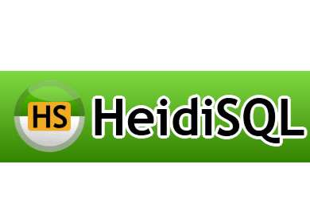

FEATURES:

* Free for everyone, Open Source
* Connect to multiple servers in one window
* Supported database systems: MariaDB, MySQL, MS SQL, PostgreSQL, SQLite, Interbase and Firebird
* [Connect to servers via commandline](https://www.heidisql.com/help.php#commandline)
* Connect via SSH tunnel, or pass SSL settings
* Create and edit [tables](https://www.heidisql.com/screenshots.php?which=table_editor), [views](https://www.heidisql.com/screenshots.php?which=view_editor), [stored routines](https://www.heidisql.com/screenshots.php?which=stored_routines), [triggers](https://www.heidisql.com/screenshots.php?which=trigger_editor) and [scheduled events](https://www.heidisql.com/screenshots.php?which=event_editor).
* [Generate nice SQL-exports](https://www.heidisql.com/screenshots.php?which=export_sql), compress these afterwards, or put them on the clipboard.
* Export from one server/database directly to another server/database
* [Manage user-privileges](https://www.heidisql.com/screenshots.php?which=usermanager)
* [Import text-files](https://www.heidisql.com/screenshots.php?which=import_textfile)
* [Export table rows as CSV, HTML, XML, SQL, LaTeX, Wiki Markup and PHP Array](https://www.heidisql.com/screenshots.php?which=export_textfile)
* [Browse and edit table-data using a comfortable grid](https://www.heidisql.com/screenshots.php?which=data)
* Bulk edit tables (move to database, change engine, collation etc.)
* [Batch-insert ascii or binary files into tables](https://www.heidisql.com/screenshots.php?which=insert_files)
* [Write queries with customizable syntax-highlighting and code-completion](https://www.heidisql.com/screenshots.php?which=query)
* Pretty reformat disordered SQL
* [Monitor and kill client-processes](https://www.heidisql.com/screenshots.php?which=host_processlist)
* [Find specific text in all tables of all databases of one server](https://www.heidisql.com/screenshots.php?which=find_text_on_server)
* [Optimize and repair tables in a batch manner](https://www.heidisql.com/screenshots.php?which=maintenance)
* Launch a parallel mysql.exe command line window using your current connection settings

APACHE TOMCAT SERVER:

It is an open-source Java servlet container that implements many Java Enterprise Specs such as the Websites API, Java-Server Pages and last but not least, the Java Servlet. The complete name of Tomcat is "Apache Tomcat" it was developed in an open, participatory environment and released in 1998 for the very first time. It began as the reference implementation for the very first Java-Server Pages and the [Java Servlet](https://www.javatpoint.com/servlet-tutorial) API. However, it no longer works as the reference implementation for both of these technologies, but it is considered as the first choice among the users even after that. It is still one of the most widely used java-sever due to several capabilities such as good extensibility, proven core engine, and well-test and durable. Here we used the term "servlet" many times, so what is [java](https://www.javatpoint.com/java-tutorial) servlet; it is a kind of software that enables the webserver to handle the dynamic(java-based) content using the Http protocols.



**ADVANTAGES:**

* **It is open-source**
* **Incredibly Lightweight**
* **Highly flexible**
* **Stability**
* **It provides us an extra level of security**
* **It is well documented**
* **It is one of the most widely used application servers**
* **It's mature**

**DISADVANTAGES:**

* It is not as fast as the Apache if we are working with the static pages
* It has some issues like a memory leak
* It's way to handle the logs.
* Issues in the SSL installations
* Its user interface is inferior and basic

**NETBEANS IDE:**

NetBeans IDE is a free and open source integrated development environment for application development on Windows, Mac, Linux, and Solaris operating systems.

The IDE simplifies the development of web, enterprise, desktop, and mobile applications that use the Java and HTML5 platforms. The IDE also offers support for the development of PHP and C/C++ applications.

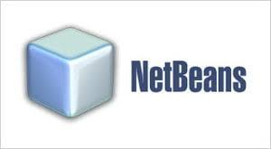

NetBeans IDE offers first-class tools for Java web, enterprise, desktop, and mobile application development. It is consistently the first IDE to support the latest versions of the JDK, Java EE, and JavaFX. It provides smart overviews to help you understand and manage your applications, including out-of-the-box support for popular technologies such as Maven.

With its end-to-end application development features, constantly improving Java Editor, and continual speed and performance enhancements, NetBeans IDE sets the standard for application development with cutting edge technologies out of the box.

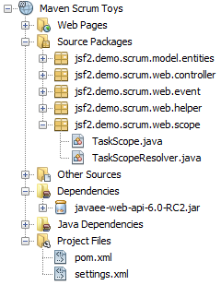

Oracle Database can be registered and accessed directly from the IDE. The IDE supports both OCI and Thin JDBC connections to the Oracle Database. Full data access features are provided out of the box, such as the ability to read, create, update and delete data directly within the IDE, supported by a feature rich SQL Editor.

The Oracle WebLogic Application Server can be registered in the IDE and applications can be deployed to it. Deployed applications, together with their related resources, can be viewed in the IDE.

In our project, we designed web pages using HTML, CSS and JAVASCRIPT

Our front-end part consists of 9 webpages

* HOME PAGE
* ADMIN LOGIN PAGE
* ADMIN HOME PAGE
* ADD FACULTY PAGE
* ADD SUBJECT PAGE
* GENERATE TIME TABLE PAGE
* VIEW TIMETABLE PAGE
* TIMETABLE DISPLAYING PAGE
* LOGOUT PAGE

All these pages are designed using HTML5 and customised using CSS.

We designed an easy and user friendly website for this project the webpages it contains are:

1.HOME:

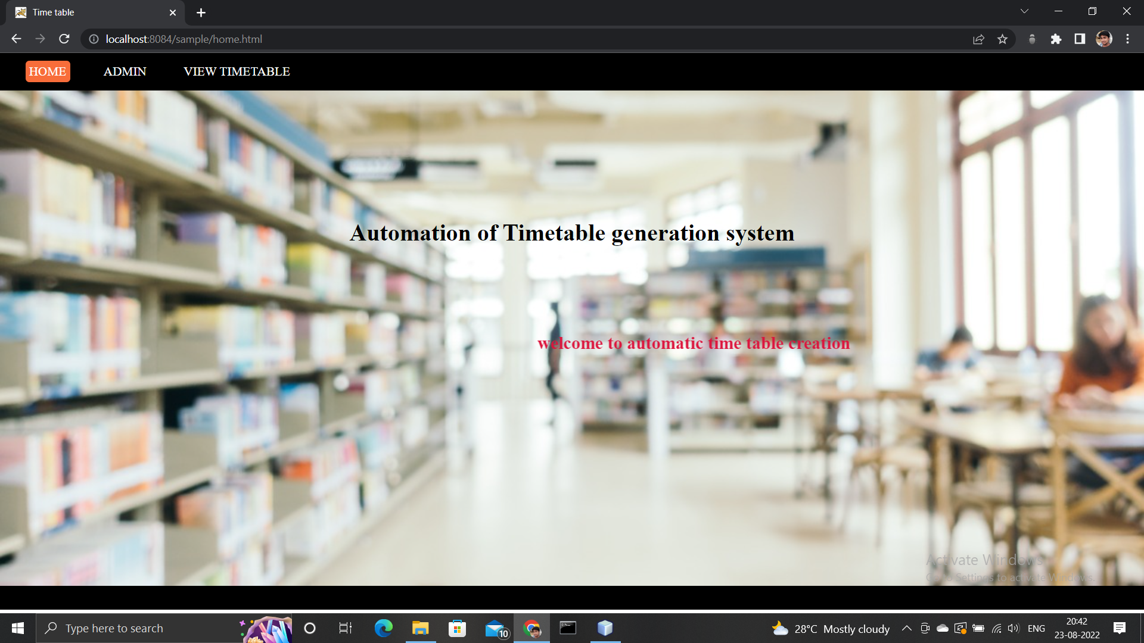

2.ADMIN LOGIN:

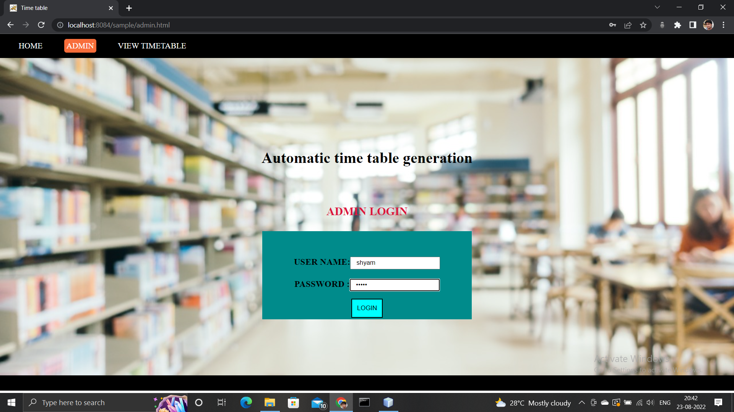

3.ADMIN HOME PAGE:

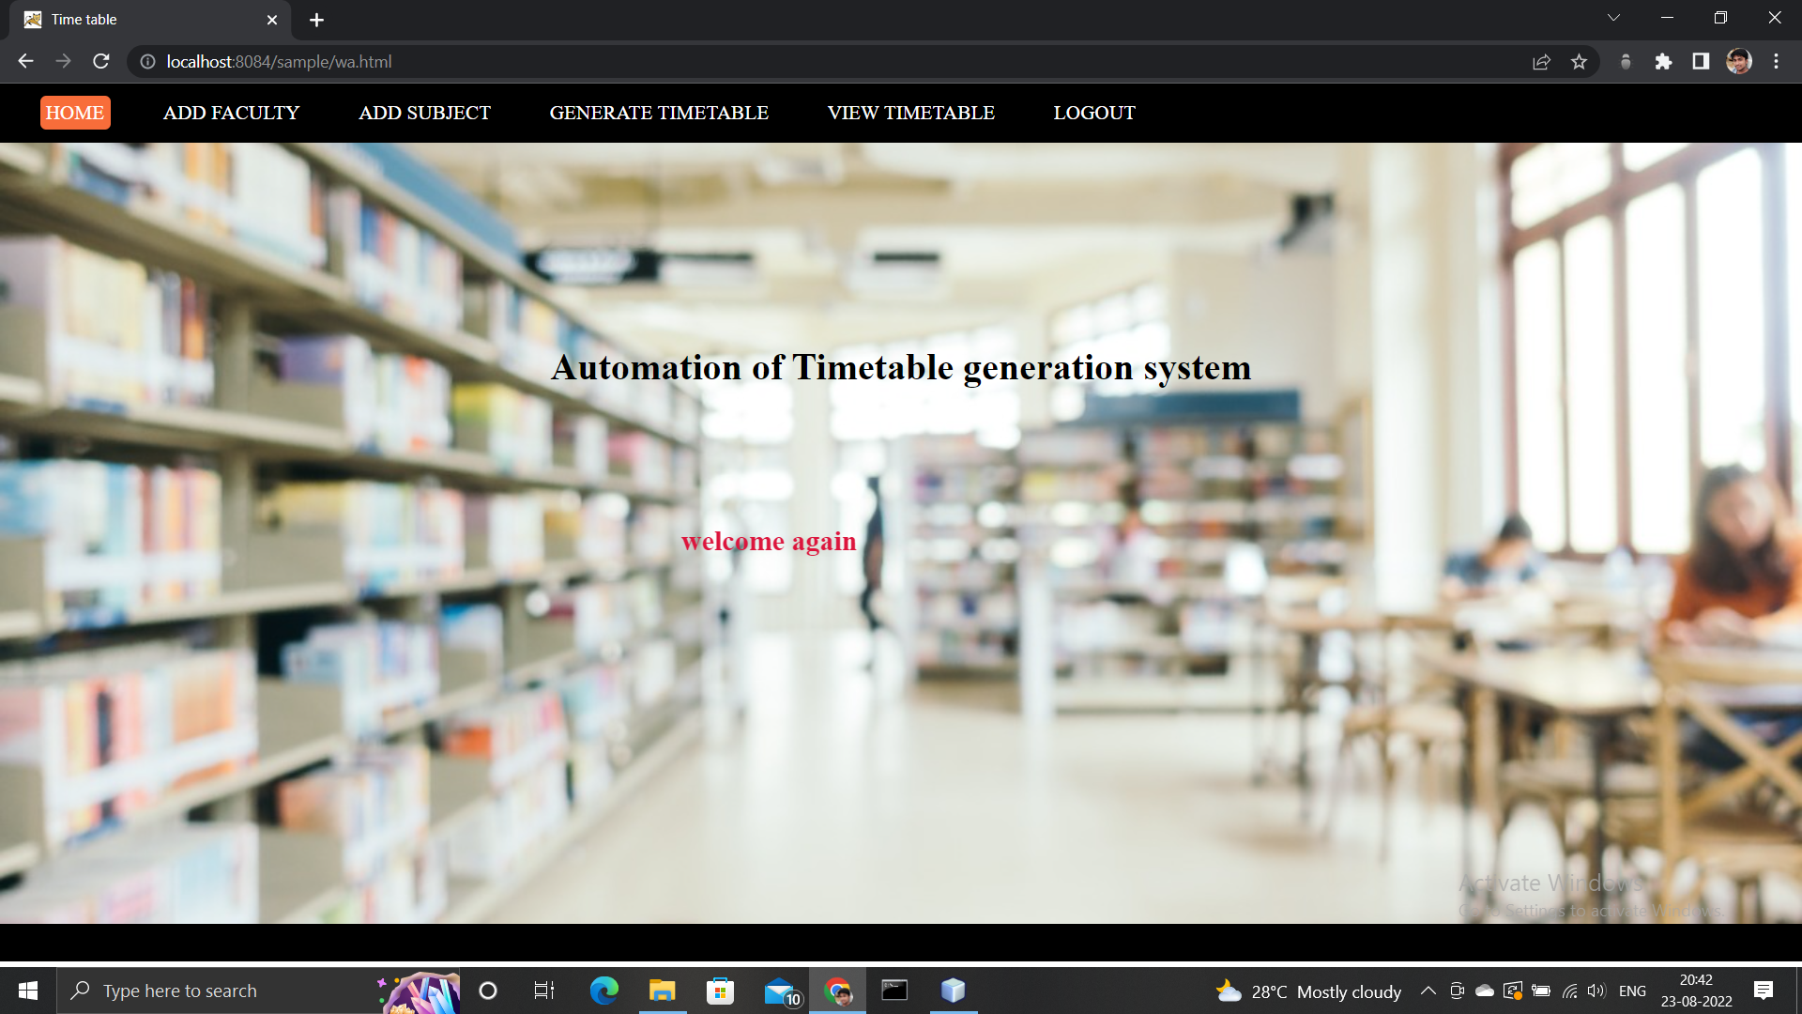

4.ADD FACULTY PAGE:

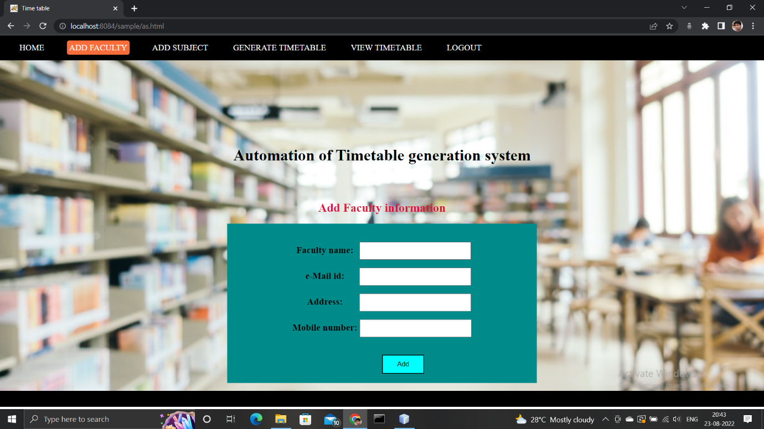

5.ADD SUBJECT PAGE:

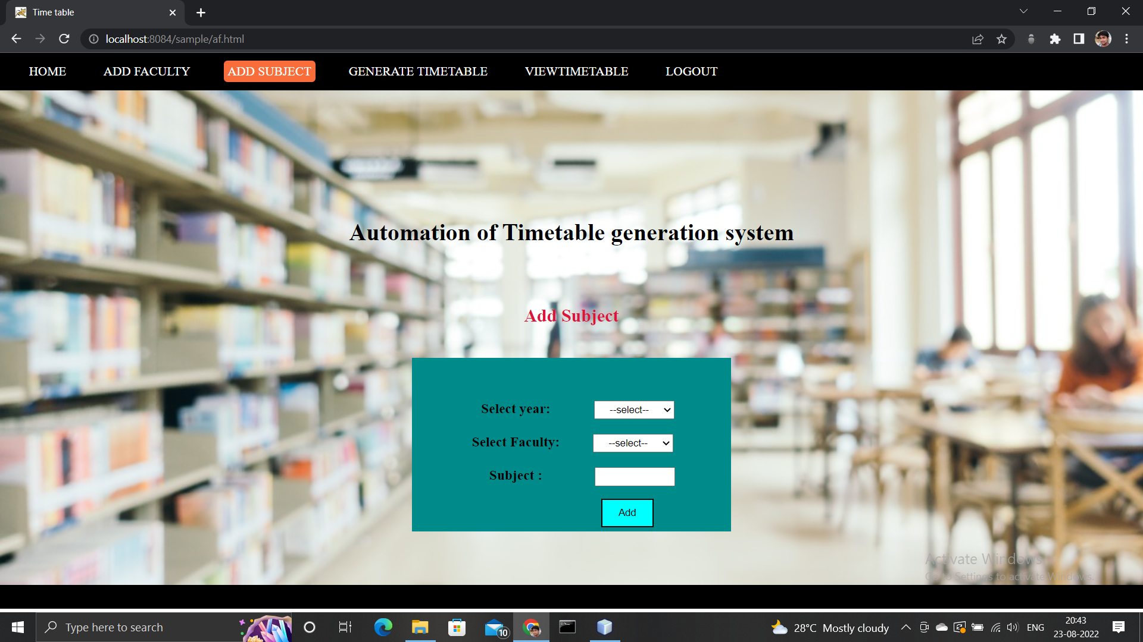

6.GENERATE TIME TABLE:

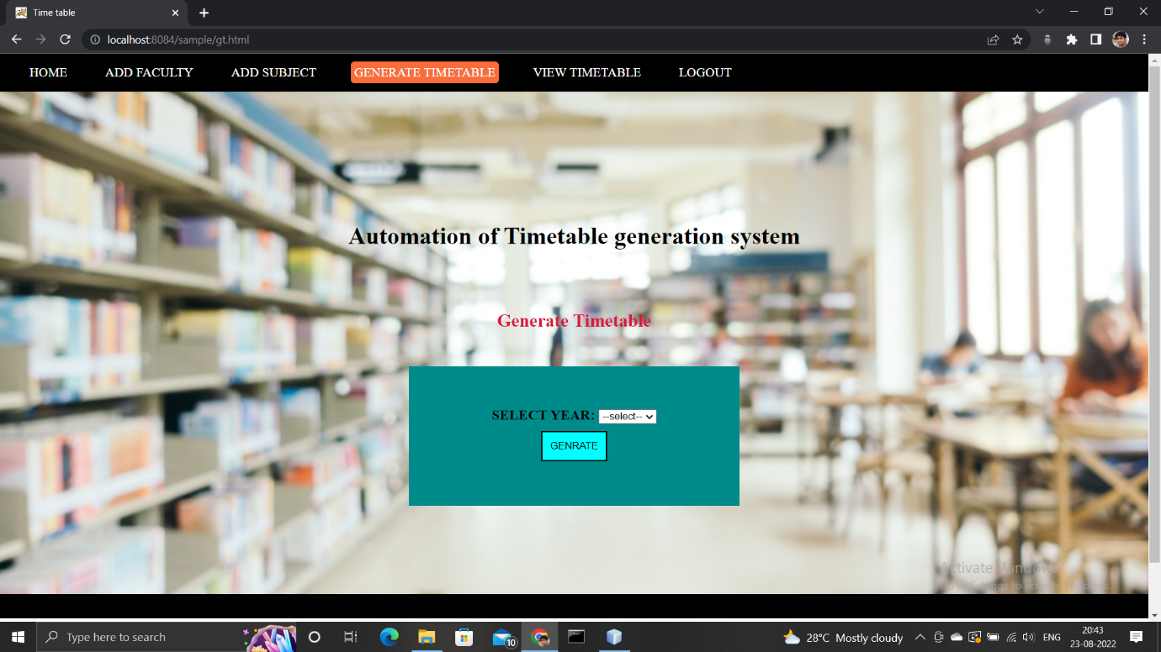

7.VIEW TIME TABLE:

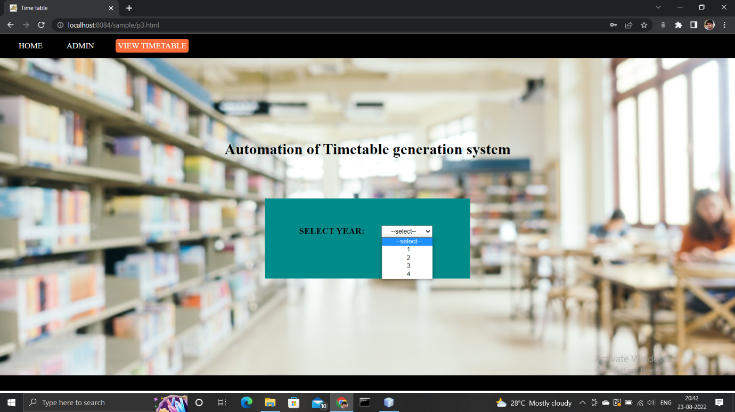

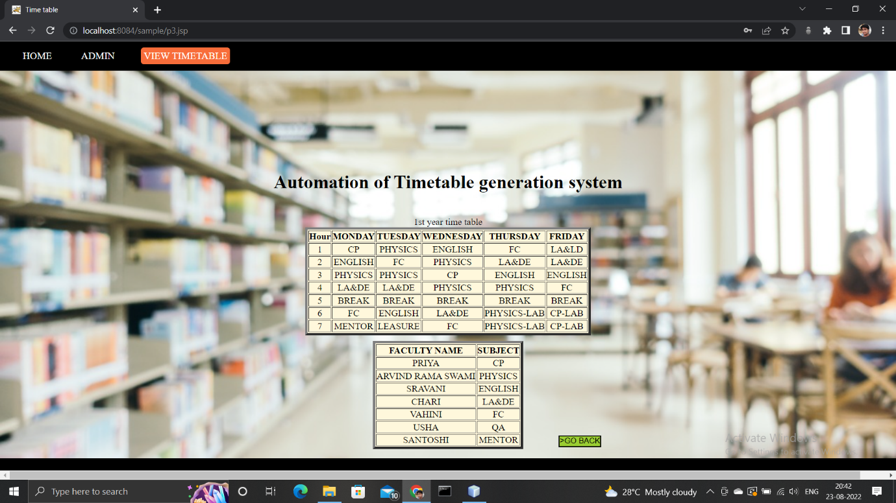

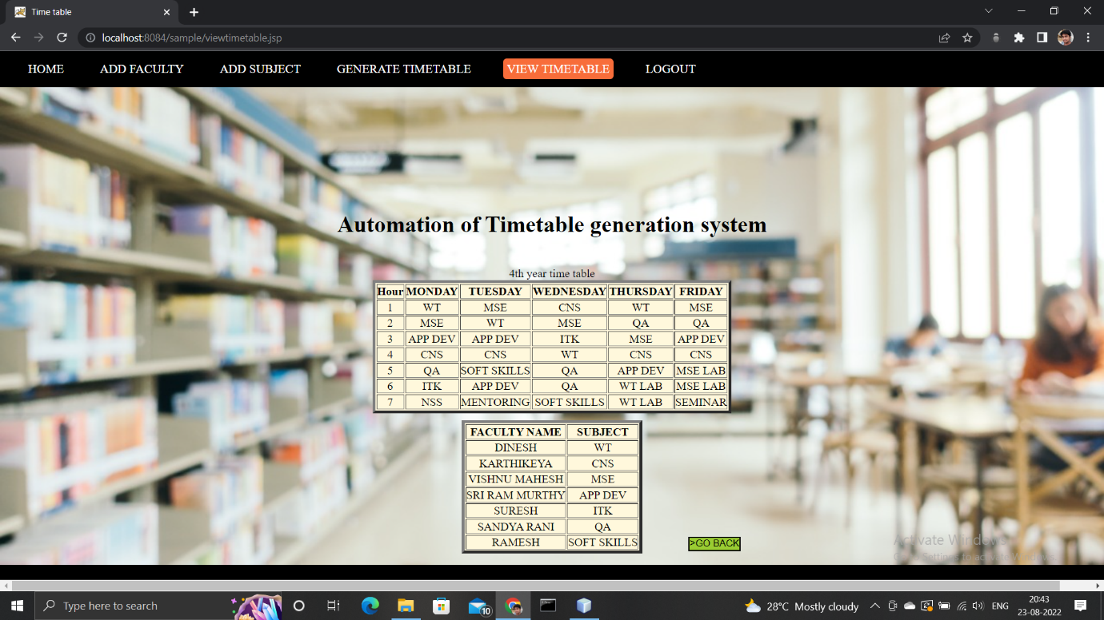

LOGOUT PAGE:

After clicking on logout button it will redirects to admin page



**APPLIACTIONS:**

CAN BE USED BY ANY ORGANISATION

**TEAM DETAILS:**

1.B. HIMA SREYA(TL)

2.D. SUSHMA

3.B. SHYAM KUMAR

4.B. VINAY

5.A. AKHILA

6.K. SOWMYA SRI VIDYA